

East West University

Department of Computer Science and Engineering (CSE)

Semester: (Summer, Year: 2025),

B.Sc. in CSE



**LAB 01**



Course Title: Internet of Things

Course Code:CSE 406

Section:01

| Students Details  Name:Seendid Saleh Kabir  ID: 2022-1-60-122 | Course Teacher’s Name:  Dr. Raihan Ul Islam  Associate Professor  Department of Computer Science & Engineering |
| --- | --- |

Submission Date: 30/6/25

**Overview:**

The first day in the lab was more about creating interest and learning the basics that we would need to learn what are the specifications of arduino, sensors, about arduino IDE and how we can use arduino and sensors, connect them using the software.

**Equipment:**  
1.Arduino

2.DHT sensor

3.Water Sensor

**Project Description:**

**Project 1 :**

**The first project was more about getting accustomed to the Arduino IDE. First created a HalloWorld file and learned about the two functions void setup() and void loop() functions that are shown in the ide.**

void setup():

Execution: Runs only once at the start of the program.

Purpose: Used for initialization tasks.

Examples:

Setting pin modes (input or output) using pinMode().

void loop():

Execution: Runs repeatedly after void setup() completes, creating a continuous loop.

Purpose: Contains the main logic and functionality of the program.

Examples:

Reading sensor values.

Controlling actuators (motors, LEDs, etc.).

Performing calculations and making decisions**.**

**Project 2:**

Lights:

There are some inbuilt LED lights in the arduino. Also there are pre used codes in the arduino libraries that we can use just by importing no need to write it again.

The code’s screenshot is given here

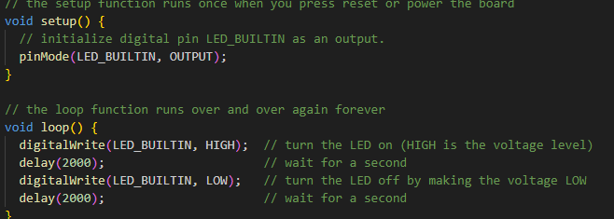

As we can see there is a delay 2 to be exact. Delay(2000) is creating a delay of 2 sec same for the second one so we have a total 4 sec delay.

**Project 3:**

DHT tester.

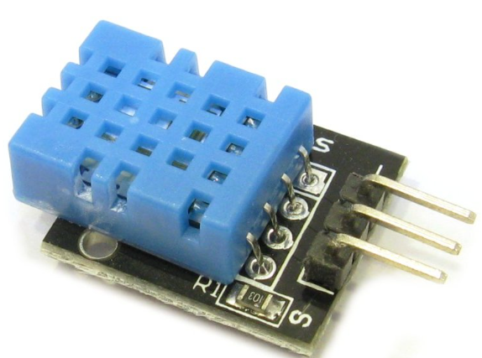

This was more of an interesting project where we used a DHT sensor.Dht sensors are used to learn about temperature and humidity around us. 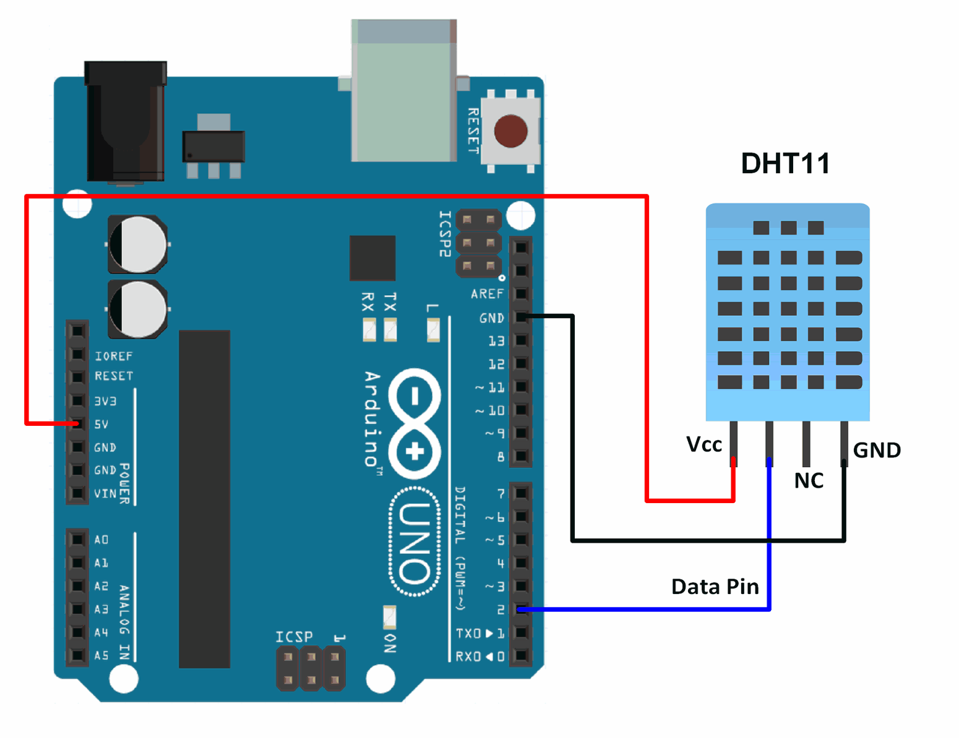

Process:

First as shown in the picture we had to make sure the + side of the sensor was connected to the Vcc and the - pin of the sensor was connected to the 3V/5V female pin of the arduino. Though we used a 3V female pin and a male to female wire to connect them.Then we had to make sure the arduino is getting the digital signal from the Dht sensor and that’s why we connected to the digital female arduino port with the sensor using a wire. After that we had to compile the code and put the code in the arduino to make sure that the code did not exceed the limit of the device.

Learnings:

1.Well we learned how to use sensors for the first time with an arduino.

2.The value of optimization because the memory in arduino is limited.

Code:

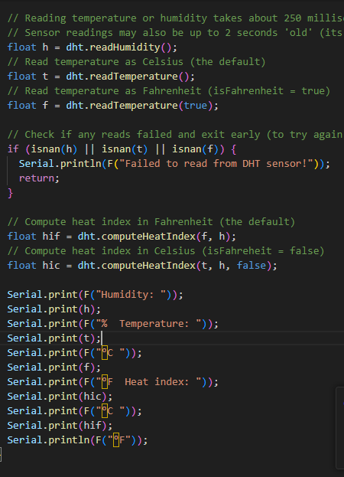  
This part in code in void loop() shows that we are taking a float data of humidity, temperature in both celsius and fahrenheit and printing it.

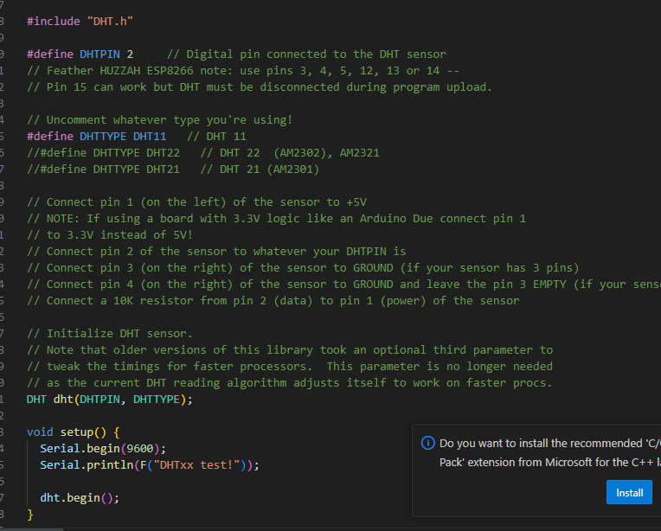

In this code we are defining the port and doing the basic setup in the void setup() function.

**Project 4:**

Water Sensor:

We used this sensor to detect water leakage, rainfall, tank overflow, or to measure the water level.

Description:

There are 3 pins in the water sensor Signal(S), Vcc(+) and Gnd(-)

We connect the signal pin with an analog port in the Arduino, Vcc to the 3v port and (-) with the GND port.

Then we just compile and upload the code from the IDE to the arduino board and check the value.

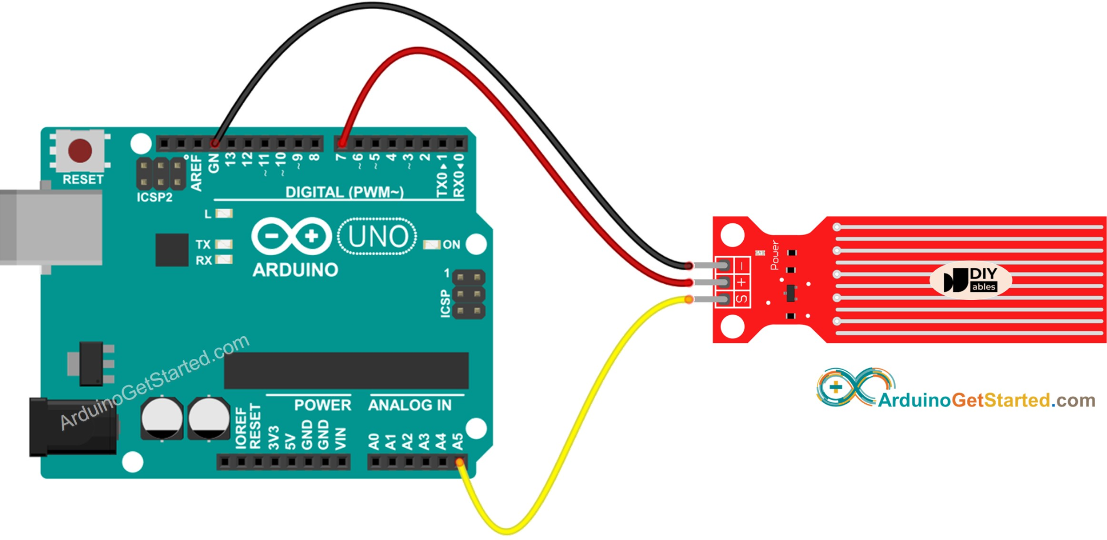

CODE:

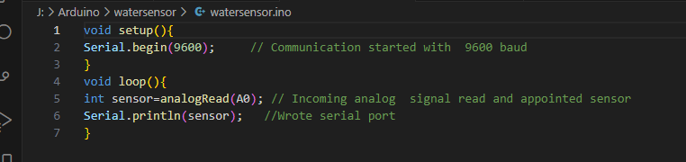

Doing the baud setup and after that reading the analog data from the water sensor and printing the data.

Link: